Project Design Phase-I Solution Architecture

Date | 06/10/2022
Team ID | PNT2022TMID33248
Project Name | Early Detection Of Chronic Kidney Disorder using Machine Learning
Maximum Marks | 4 Marks

Solution Architecture:
Solution architecture is a complex process – with many sub-processes – that bridges the gap between business problems and technology solutions.
Our solutions are,
- To provide a prediction algorithm to predict Chronic Kidney Disorders at an early stage..
- The dataset shows input parameters collected from the CKD patients and the models are trained
and validated for the given input parameters.
- Decision tree, Random Forest and Support Vector Machine learning models
are constructed to carry out the diagnosis of CKD.
- The performance of the models are evaluated based on the accuracy of prediction.

Solution Architecture Diagram:

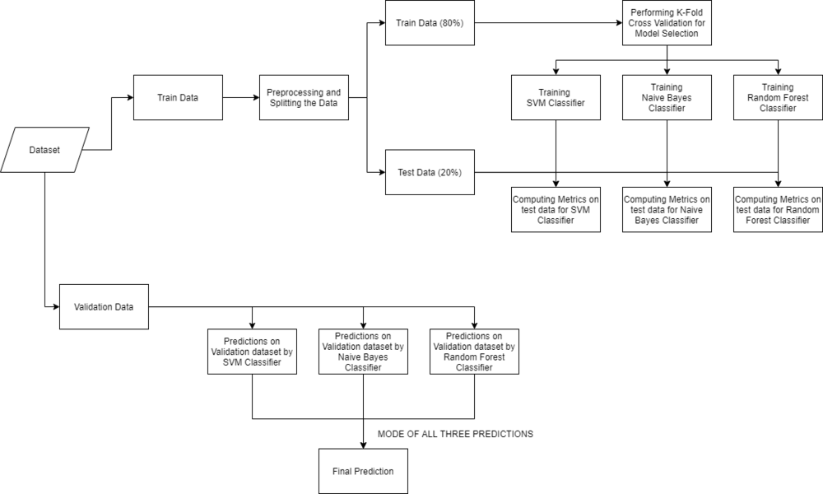
OVERALL ARCHITECTURE

